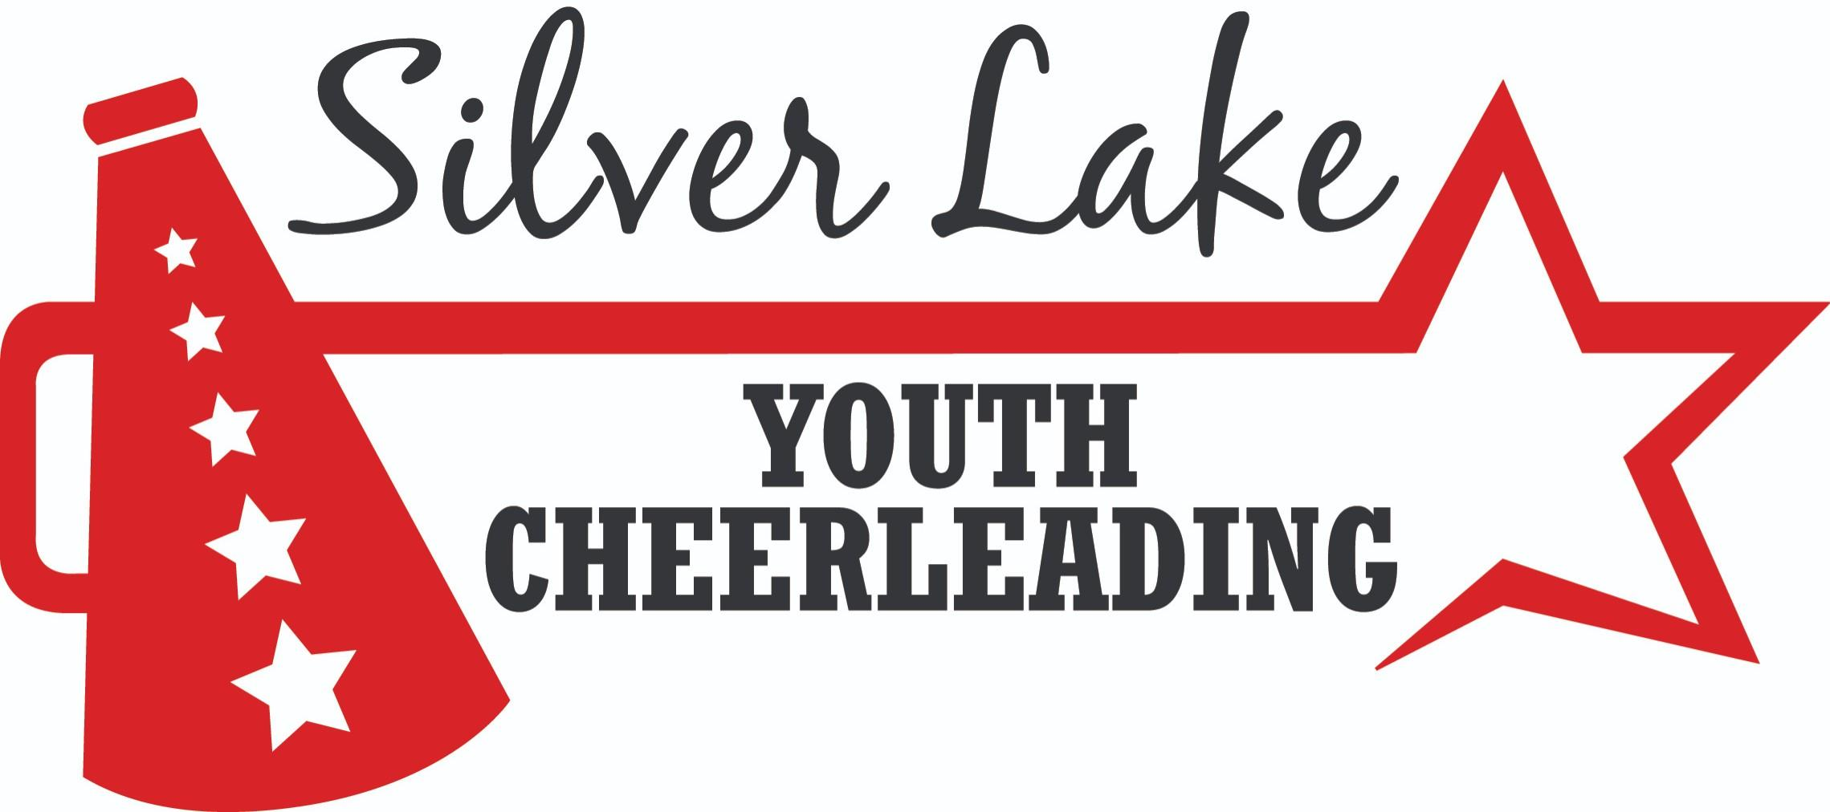

We have provided you with highlights of the SLYC Program below.
Please take the time to read all information before you register with SLYC.

Registration:
- Registration will begin April 1, 2021 and ends May 1, 2021
- Cost includes -tumbling, choreography, clinic, competitions
- No refunds after July 1, 2021
- For safety reasons our teams have a capacity of 25 cheerleaders. Any additional cheerleaders over 25 will be placed on a wait list. If an opening comes about you will be notified in order of registration.

Cheerleading Season:
- All cheerleaders must participate in Camp/Choreography, Practices, Football Games (home & away), and any competition we have entered. Any cheerleader having to miss any portion of this schedule must notify the Executive Board & Coach as soon as possible for special consideration. Further details on our attendance policy are available in the Attendance Policy document.

- Mandatory Camps:
These will occur in August. Camps are on multiple days and are for skill development and choreography.

- Summer Practices:
Summer practice will start at the beginning of August (exact date TBD) and run on Tues, Wed & Thurs from 5:30p-7:30p. Practices are held outside.

- September-November Practices:
Practices move inside the first week of September. Three (3) days of practice will be held for 2020. Mondays will be held for private SLYC tumbling. Cheerleaders will practice for 1hr dedicated to improving tumbling skills (details TBD). Each squad will hold 2 days of practice on either Tues, Wed or Thurs. (squad specific days TBD). We reserve the right to increase to three (3) as we get closer to competition.

- Football Season:
Teams cheer at both home and away games. The season runs from September through November (including playoffs and the division Superbowl as applicable). Games are typically held on Sundays with occasional Saturday nights. Transportation is not provided. Game calendar with locations will be posted on our web page as soon as its available.

- Competition:
Silver Lake Youth Cheerleading participates in up to four (4) competitions during the season (typically end of October to Mid November). More information on this will be provided at the Parent meeting.

Expected Costs:
In addition to the registration and tumbling fees, parents must cover the following expenses (this is a summary and other small expenses may pop up during the season).

- Required Uniform Accessories:
This generally includes *briefs, *body liner, cheer sneakers, bow(s) and white no show socks. Total for the first year runs approximately $150 - $200 (*items generally do not need to be replaced year after year if they are purchased with some growth in mind).

- Optional Costs:
Pictures, winter gear and other SLYC gear are offered for additional costs but are not required to be purchased.

- A uniform deposit of $150 is required before a cheerleader will be allowed to receive his/her uniform. The deposit should be made by check and dated 12/1 of the current year. Uniforms are the property of Silver Lake Youth Cheerleading, Inc and the deposit will cover the cost of the vest and skirt. The deposit will not be cashed if the uniform is returned cleaned and not damaged/altered.

Fundraising:
- Fundraising is a necessary part of our organization. It allows us to keep costs down and be able to invest in SLYC in order to keep growing the program in the ever changing world of cheerleading. It is expected that every family participates in all fundraising efforts.

YOU ARE NOW READY TO REGISTER!
Please travel back to the home page and click on the Registration Tab for step by step instructions

Thank you and we look forward to a great season

